\INFS3208 - 2019 Semester 2 Exam
Please contribute and add your solutions to the exam here :)

Q1)
a) What are horizontal scaling and vertical scaling? (2 marks)

Horizontal scaling: allocating/releasing IT resources. Done by adding more IT resources.
Vertical scaling: higher/lower IT resources. Requires upgrading hardware on existing resources.
+1+2

b) What are the cloud delivery models and corresponding characteristics? Please give an example for each delivery model. (6 marks)

Infrastructure As A Service: self-contained virtual environment of infrastructure-centric IT resources. +2
User: system administrator. Example: Google compute Engine, Amazon EC2, Azure.+2

Platform As A Service: pre-defined ‘ready-to-use’ environment consists of already prepared and configured IT resources. +2
User: developer. Example: Google app Engine, AWS Elastic Beanstalk.+2

Software As A Service: a shared cloud device and made available as a product. +2
User: end-user. Example: Google Ecosystem, Microsoft Office.+2
+1

Q2)
a) What are the cloud-enabling technologies? (2 marks)
Broadband network and Internet Architecture
Virtualisation Technology
Data Centre Technology
Web Technology
Multitenant Technology
+1+2

b) Compare similarities and dissimilarities between the container and virtual machine technologies. (5 marks)
Containers are cheaper, more efficient, use less memory, are resilient, can be replicated more easily and hundreds more containers can run on a device than a VM.+2

A virtual machine uses more storage and memory, cannot be replicated easily, is usually less efficient and you are only able to run a very small number of VMs on one machine at a time.
+1+2

Q3)
a) What is Resilient Distributed Dataset (RDD) in Apache Spark? (1 mark)
RDD is a fundamental data structure in Spark.
RDD is a read-only (immutable) distributed collection of objects/elements.
+1+2

b) How many ways are there to create an RDD in Apache Spark? (1 mark)
Transformations are operations that return a new RDD.
map(func), filter(func), flatMap(func), mapValues(func), union(func), reduceByKey(func)

Wouldn’t it be two ways: textFile(.) and parallelize(.) [slide 59 in revision slides] ? yes +1

c) What is the lazy evaluation mechanism in Apache Spark? (2 marks)
Transformations in Spark RDDs are evaluated or computed in a lazy manner: which means it will not begin to execute until it sees an action.
The lazy evaluation means that when transforms on RDD are called, the operations are not immediately performed.
Spark internally records metadata to indicate that this operation has been requested.
Spark can decide what is the best way to perform a series of transformations that are recorded.
Spark uses the Lazy Evaluation to reduce the number of passes (storage on disk).
+1+2

Q4)
a)
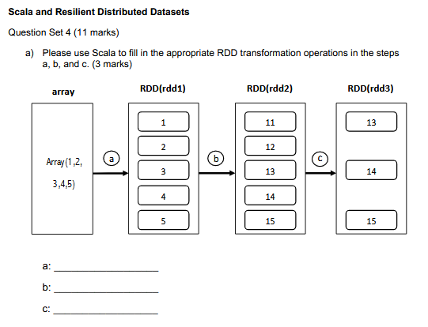
A: sc.parallelize(Array) val rdd1 =sc.parallelize(array)
B: rdd_a.map(x=>x+10) val rdd2 = rdd1.map(x => x+10)
C: rdd_b.filter(x=>x>12) val rdd3 = rdd2.filter(x=> x>12)+2

b) Given a list of student records that consist of student numbers and course scores, please write a Scala program to (i) load the data into an RDD, (ii) calculate the average score for each student, and (iii) display the students whose average score is greater than 70. (8 marks) ---- FOR INFS7208
Raw data:
"s123456",78
"s123456",80
"s123456",65
"s123456",90
"s654321",80
"s654321",40
"s654321",50
"s654321",90
"s654321" 80

i)
rdd1 = sc.textFile()

ii)
rdd2_tmp = rdd1.groupByKey(.)
rdd2 = rdd2_tmp.map(func)
which I reckon the func should be: Average = A.sum / A.size

iii)
rdd3 = rdd2.filter(x => x>70)

I think that is a different question that you answered ^

(b)
i) val rdd1 = sc.cartesian(parallelize(collection)) ???

ii) val rdd2 = sc.parallelize(collection).sum()

iii) val rdd3 = sc.parallelize(collection).count()

iv) val rdd4 = sc.parallelize(collection).takeSample(false, 4)

My answer may be easier to read ：）
（B）
1.
val rdd = sc.parallelize(collection).reduce(_*_)
OR
val rdd = sc.parallelize(collection).reduce((x,y)=>x*y)
2.
val rdd = sc.parallelize(collection).reduce(_+_)
OR
val rdd = sc.parallelize(collection).reduce((x,y)=>x+y)
3.
val rdd = sc.parallelize(collection).count()
4.
val rdd = sc.parallelize(collection).takeSample(false, 4)

Q5)
a) Compare RDD with DataFrame? (3 marks)
RDDs are immutable distributed collections of data, partitioned across the nodes in clusters and can be operated in parallel with a low-level API that offers operations (i.e. transformations and actions).
DataFrames are immutable distributed collections of data. But it is organized into named columns, like tables in relational databases.
DataFrame is designed to make large datasets processing even easier than RDDs (better version than RDD).
No-structured data manipulation (RDD) vs Large structured data query (DataFrame).+2

b) Describe each step in the READ operation in Google File System (GFS). (5 marks)
- When an application is reading a file, the app needs to go to the GFS client server, the client then sends the file name and chunk index to the GFS master. e.g.The app wants to read the 5th chunk of a particular file.
- After receiving the request, the GFS master will check its table and return the ID of the chunk and all chunk server IP addresses where that chunk has replicas.
- The GFS client client can then directly go to the closest chunk server and read data.
- The GFS client doesn’t directly read the data from the master. It only reads a metadata and the actual reading and writing is done between GFS client and chunk server.
- To further reduce the GFS master load, the GFS client cache the chunk operation and chunk location.
+2

Q6)
a) What are CAP theorem and BASE properties? (5 marks)
The CAP theorem states that it is impossible for a distributed data store to simultaneously provide more than 2 out of the following guarantees:
- Consistency: Every read receives the most recent write or error.
- Availability: Every request receives a (non-error) response, without the guarantee of the most recent.
- Partition tolerance: The system continues to operate despite some of the messages being dropped or delayed by the network between nodes.
+2
BASE in Nosql: The opposite for ACID for transactions in relational database
- Basically Available: one distributed system has a failure part but the total system working properly.
- Soft-state: corresponding to the strong state, which guarantees consistency and durability, and allows delays and outages (in short periods).
- Eventually-consist: strong-consist means every transaction needs to be consistent, but in a distributed system, it is enough to eventually be in a consistent state.

+2
b) What are the implementation options of Cassandra and HBase, respectively? (2 marks) NA
Cassandra - AP
HBase - CP

Q7)

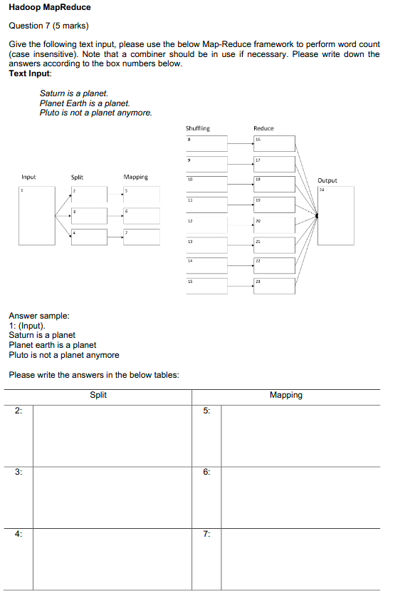

Split | Mapping
2: (saturn, is, a, plant) | 5:(saturn,1) (is,1) (a,1) (plant,1)
3: (plant, earth, is, a, plant) | 6:(planet, 1) (earth, 1) (is, 1) (a,1) (planet, 1)
4: (pluto, is, not, a, planet, anymore) | 7: (pluto,1) (is, 1) (not,1)(a,1)(planet,1)(anymore,1)

Shuffling | Reduce
8: (saturn,1) | 16: (saturn,1)
9: (is,1)(is,1)(is,1) | 17: （is,3)
10: (a,1)(a,1)(a,1) | 18: (a,3)
11: (planet,1)(planet,1)(planet,1)(planet,1) | 19: (planet, 4)
12: (earth,1) | 20: (earth,1)
13: (pluto,1) | 21: (pluto,1)
14: (not,1) | 22: (not, 1)
15: (anymore,1) | 23: (anymore,1)

Is the Shuffling supposed to be like K2,List(V2) in Hadoop MapReduce? ---- Lecture slide 9-22
So that, for 9,10,11 it should be like: is, (1,1,1) a, (1,1,1) planet, (1,1,1)

Output
24: (saturn,1)（is,3) (a,3) (planet, 4) (earth,1) (pluto,1) (not, 1)
(anymore,1)

+200

